Save The Bird

By

**Mahmuda Yeasmin Omi**

Roll No: 17CSE031

A project submitted in partial fulfillment of the requirements for the degree of

Bachelor of Science in Computer Science and Engineering



Department of Computer Science and Engineering

Bangabandhu Sheikh Mujibur Rahman Science and Technology University

Gopalganj 8100, Bangladesh

July 2023

**Save The Bird**

**by**

**Mahmuda Yeasmin Omi**

Student ID: 17CSE031

**Supervised by**

## Md. Monowar Hossain

Assistant Professor,

Department of Computer Science and Engineering,

Bangabandhu Sheikh Mujibur Rahman Science and Technology University,

Gopalganj-8100, Bangladesh.

Submitted to the Department of Computer Science & Engineering,

Bangabandhu Sheikh Mujibur Rahman Science and Technology University

**Declaration**

This is to certify that the project work entitled “Save The Bird” has been carried out by Mahmuda Yeasmin Omi in the Department of Computer Science and Engineering (CSE), Bangabandhu Sheikh Mujibur Rahman Science and Technology University, Gopalganj, Bangladesh. The above project work or any part of this work has not been submitted anywhere for the award of any degree or diploma.

Signature of Supervisor Signature of Candidate

(Md. Monowar Hossain) (Mahmuda Yeasmin Omi)

**Abstract**

In our regular point of view, gaming is fun, and learning is boring. Games motivate players to take risks and actions, persevere through failures, set, and achieve increasingly difficult goals, and devote attention, time, and effort to acquiring knowledge and skills which are the main key to acquiring knowledge. One can stay on playing games all day but can’t give perfect determination to study for a single hour. If we can combine gaming and learning all together, we will be able make the environment of learning fun. This article describes Save the Bird game that contains C++ language programming so that we can go forward in our way of learning C++ with fun.

**Acknowledgment**

All the praise to the almighty Allah as He let me complete this project work successfully. My sincere gratitude is extended to Md. Monowar Hossain sir, who served as both my project supervisor and honorary mentor and provided me with a wealth of guidance. His ongoing, astute guidance gives me the best instructions for finishing the project flawlessly. He provides me with numerous guidelines regarding what topics should be the emphasis of my project. I'm appreciative of my project advisor's sensible advice. I therefore want to express my sincere gratitude to my supervisor for his guidance and cooperation. I have received a lot of direction, inspiration, and encouragement while working on my project. Finally, I would like to thank my parents for their constant support and encouragement throughout my studies.

Mahmuda Yeasmin Omi

July,2023

**Table of Content**

|  |  |  |  |
| --- | --- | --- | --- |
| Serial No | Section No | Description | Pages No |
| 1. |  | Acknowledgement | iv |
| 2. |  | Abstract | v |
| 3. | Chapter 1 | Introduction and Overview | 1 |
| 4. | 1.1 | Introduction | 1 |
| 5. | 1.2 | Background | 1 |
| 6. | 1.3 | Motivation | 1 |
| 7. | Chapter 2 | Literature Review | 2 |
| 8. | Chapter 3 | Specifications | 3 |
| 9. | 3.1 | Project Perspective | 3 |
| 10. | 3.2 | Hardware Specification | 3 |
| 11. | 3.3 | Software Specification | 3 |
| 12. | Chapter 4 | Implementation | 4 |
| 13. | 4.1 | Coding | 4 |
| 14. | 4.2 | Testing | 4 |
| 15. | 4.3 | Physical Design | 4 |
| 16. | 4.4 | Home Page | 5 |
| 17. | 4.5 | Instruction Page | 5 |
| 18. | 4.6 | Start Page | 6 |
| 19. | 4.7 | Gameplay | 7 |
| 20. | 4.8 | Game Over Page | 7 |
| 21. | Chapter 5 | Limitation & Future Work | 8 |
| 22. | 5.1 | Limitation | 8 |
| 23. | 5.2 | Future work | 8 |
| 24. | Chapter 6 | Conclusion | 9 |
| 25. |  | References | 10 |

**LIST OF FIGURES**

**Figure No.**   **Description**   **Page**

Figure 4.1: System Flow 04

Figure 4.2: Home Page 05

Figure 4.3: Instruction Page 05

Figure 4.4: Start Page 06

Figure 4.5: Gameplay 06

Figure 4.6: Gameplay (cont.) 07

Figure 4.7: Game Over Page 07

**Chapter 1**

**Introduction and Overview**

**1.1 Introduction**

By definition, a game is simply a structured form of play that excites the senses and captivates players. Unlike regular teaching, a well-developed game can instinctively convey meaningful content. Generally, C++ programming is the second programming language of any programmer. So, it is very important to learn this language clearly.

Many of us are not interested in learning this language. But first this language encourages a student to be a successful programmer. This can be learnt in an interesting way. And if that way will be gaming, it be a better one.

**1.2 Background**

I was a newcomer at the department of Computer Science and Engineering in BSMRSTU then. My beginning C++ programming class was difficult for me, and I sometimes can’t understand some classes. C++ was very difficult for me. That is why I was so disappointed at learning C++ language. I thought that if there was a game about it. It will be interesting for us to learn C++ language.

**1.3 Motivation**

I decided to make this kind of game as my project and hope that it will be very helpful for the newcomer students. I want this kind of project to make them happier to learn C++ language.

**Chapter 2**

**Literature review**

Like this game there are a lot of games are available. There are some quizzes game with different question. They are.

2.1 Math skill.

2.2 Simple question.

2.3 Faster programming

**Chapter 3**

**Specifications**

**3.1 Project Perspective**

It is a fun game created with C++ language that I made needs cpp file. Without this file do not support properly.

**3.2 Hardware specifications**

* Processor : Intel(R) Core(TM) i5-1035G1
* SSD : 512 GB
* RAM : 8 GB
* Processor clock speed : 1.00GHz-1.20 GHz Clock Speed

**3.3 Software specifications**

* Operating System : Windows 7, 8, 10,11 or Linux
* Software : CodeBlocks

### Chapter 4

### Implementation

Implementing this project "Save The Bird" is not a very short time project. It is created in the C++ language on CodeBlocks platform. It took a long time to make this project. There is also a necessity of having the knowledge of C++ language. Implementation is the process of putting the proposed system into operation. Some of the activities undertaken by the analyst are tanning personnel who will use the system. There is also provision of user manual and help page for efficient use of the system.

#### 4.1 Coding

Coding is the construction of the actual system using a specific language. For the application, I must use C++ language to implement the project.

#### 4.2 Testing

Testing is the process of verifying and validating the system for the performance with specification and meeting the customer requirements.

**4.3 Physical Design**

Figure 4.1 is the flow figure for Save The Bird.

Main Menu

Select Option:

Press 3

(For Exit the game)

Press 2

(For see the instruction)

Press1

(For Start the game)

**Figure 4.1: System flow**

**4.4 Home Page**

The main window represents the overview of the game. When the user run the game the main window of the game will be appeared to the user. The main window given in the below:

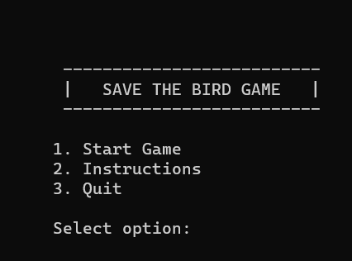

**Figure 4.2: Home Page**

**4.5 Instructions page**

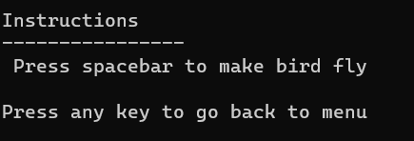After selecting option 2 there will be shown an instructions page and user understanding the rules.

**Figure 4.3: Instructions Page**

**4.6 Start Page**

After selecting option 1 the game will start. Then the bird comes to the user and the user must playing the game by pressing spacebar. Press any key to start.

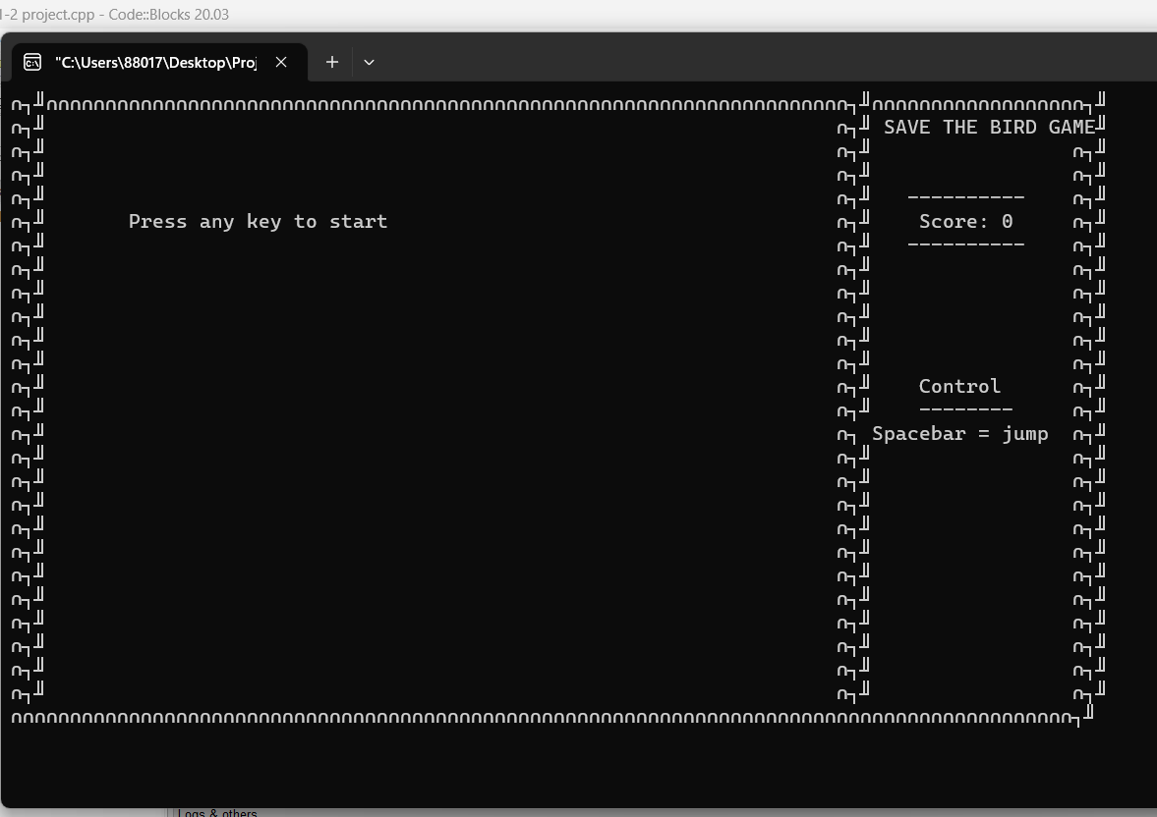

**Figure 4.4: Start Page**

**4.7 Gameplay**

After pressing any key, the game will start, and the bird comes to the user.

**Figure 4.5: Gameplay page**

It is a simple game in which one bird is moving between different obstacles. Every time the bird crosses any obstacle the score increases by 1. If the bird touches any obstacle, then the game will end and the total score will show on the screen**.**

**Figure 4.6: Gameplay (Cont.)**

**4.8 Game Over Page**

The goal is to get past the obstacles without getting detracted by everything always changing. If you touch the ground or an obstacle you lose. In this game, the objective is to pass through all the obstacles and not hit the ground or the obstacles.

**Figure 4.7: Game Over page**

**Chapter 5**

**Limitation & Future Work**

**5.1 Limitations**

* Lack of Visual Appeal
* Limited Gameplay Realism
* Lack of Sound Effects
* Absence of Animations
* Increasing more levels

**5.2 Future Work**

* We want to create the bird rotating effect when jumping or falling.
* Also, we can increase the game difficulty by decreasing the gap between pipes as time goes on.
* Finally, we can increase the game difficulty by making pipes move up and down as time goes on.
* Create time-based challenges where the player must complete the course within a specific time limit to earn additional points or rewards.

**Chapter 6**

**Conclusion**

**6.1 Conclusion**

Currently, we are living in a digital era. To utilize digital systems, we should know about programing. Now to carry on with the world we should know about digitalism. Regarding programming I think my game will be very helpful. It is very friendly to the user. Save The Bird game can be created using any programming language. I chose the C++ language because it is easy to use and easy to implement game logic. Creating Save The Bird in C++ provided an opportunity to improve our programming skills, especially in areas like conditional statements, loops, and collision detection.

**References**

* <https://www.onlinegdb.com/online_c_compiler>
* http://://www.youtube.com/watch?v=FvyTf85cT_0&list=PLiOa6ike4WAFOn 9oStv0YI9QMcCVzv-AV